**LAB – 10**

18MIS7250

Amit Kumar Sahu

**DHCP**

Dynamic Host Configuration Protocol (DHCP) is a network management protocol used to automate the process of configuring devices on IP networks, thus allowing them to use network services such as DNS, NTP, and any communication protocol based on UDP or TCP.

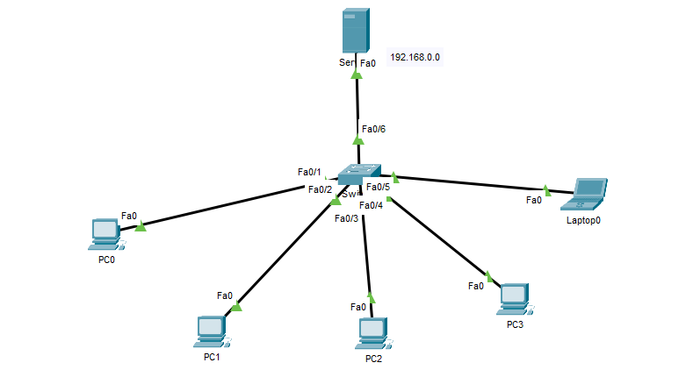

As the requesting client has no IP address when joining the network, it broadcasts the request. The protocol is thus used in a very early stage of IP communication. If such dynamic protocol is not used to get an IP address, the client has to use a predefined IP address generally called “static IP address”, which is manually configured on the client network interface in configuration files or with a specific command.

The DHCP service brings three key values:

1) Operation tasks are reduced: the network administrator no longer needs to manually configure each client before it can use the network

2) The IP addressing plan is optimized: addresses no longer being used are freed up and made available to new clients connecting

3) User mobility is easily managed: the administrator doesn’t need to manually reconfigure a client when its network access point changes.

**Configuring DHCP in all PC’s and laptop**

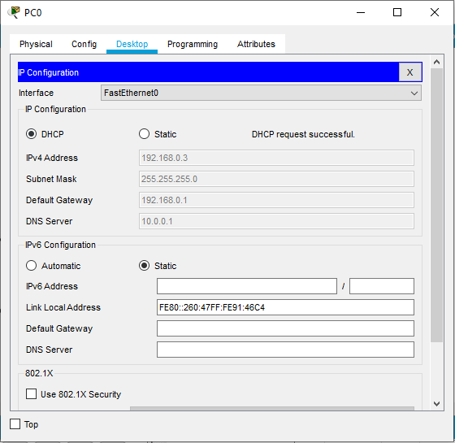

**Verifying the DHCP network by running in simulation**

